Making Comics / Comics and Games

Questions

‘Making Comics / Comics and Games’ is a practice research project led by Professor Christopher Murray. It explores the process of making comics and methods of co-design and collaborative authorship, and also the relationship between comics and games. It is primarily directed at those working in the creative economies, though anyone can participate (however, everyone who participates must read the information sheet and complete and return the informed consent form along with their answers). Please feel free to answer some or all of the questions. Responses and the completed informed consent form should be sent via email to Professor Christopher Murray (c.murray@dundee.ac.uk).

1/ The initial stages of making a comic often involve producing a script, and from there, character designs, layout sketches, then pencils, inks, etc. Is there an equivalent process in game design? If there anything close to a script that sets out a story and dialogue, and gives instructions to artists/designers about the characters and world? Or do games employ storyboards in the same ways that films do?

2/ This is a question about the collaborative process. Comics are often made by small teams. There can be just one creator involved who writes and draws the whole comic, but often there will be a writer and an artist. Sometimes there is a separate letterer and a colourist. If a comic is being published by a large publisher there may be an editor. How many people are involved in creating a game at the various stages of development? What roles do they take on?

3/ What connections/similarities or differences to you see between the medium of comics and the medium of video games?

4/ On the surface, comics tell stories, and games are about gameplay and interactivity. Games scholars often draw a distinction between narratology and ludology. What do you think about this distinction? Do games tell stories or are they fundamentally about something else? (There are some more questions related to this at the end of this document).

5/ Comics scholars like Scott McCloud argue that comics are inherently interactive. The economical mode of storytelling employed by comics means that the reader has to fill in the gaps with their imagination. This results in a kind of ‘play’ where meaning is negotiated in the interaction of word and image and between panels on the page. Do you think the ways in which comics are interactive is comparable to interactivity in games, or is it quite different?

6/ Comics are increasingly read online and sometimes digital comics have limited interactive elements. What potential convergences do you see between comics and video games in the future?

7/ There have been several experiments with branching comics using a ‘choose-your-own-adventure’ structure, but these have often been seen as gimmicky and have rarely worked in terms of balancing satisfying storytelling with immersive interactivity. Do you think games technology might offer a way to successfully combine the two? What are the challenges and opportunities?

8/ Games have often been developed from IP that originated in comics and there have been many comics based on computer games. Are there any particularly successful (or unsuccessful) examples?

9/ Crossovers between comics and video games happened at a very early stage and were seen on the home gaming consoles of the 1970s and ‘80s. 1979 saw the release of Superman for the Atari, programmed by John Dunn. It followed the huge success of Superman: The Movie (1978), but graphics and gameplay were very basic, with no sideways scrolling. Instead, when Superman reached the edge of the screen it was replaced with a new one. Atari released Spider-Man in 1982. The game sees Spider-Man scaling buildings and slinging across to walls (avoiding the windows) in order to defuse bombs that have been scattered around the city by the Green Goblin.

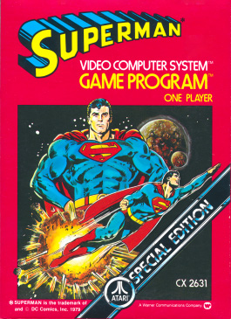

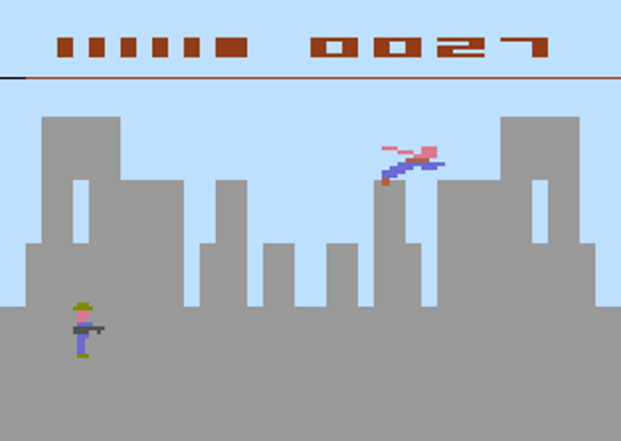

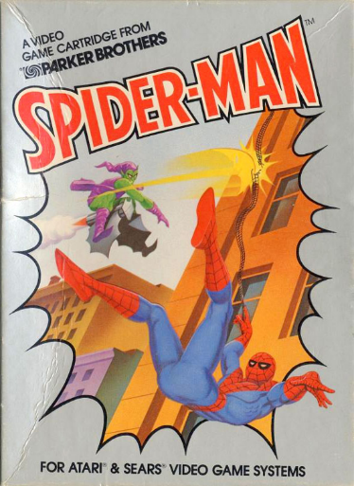

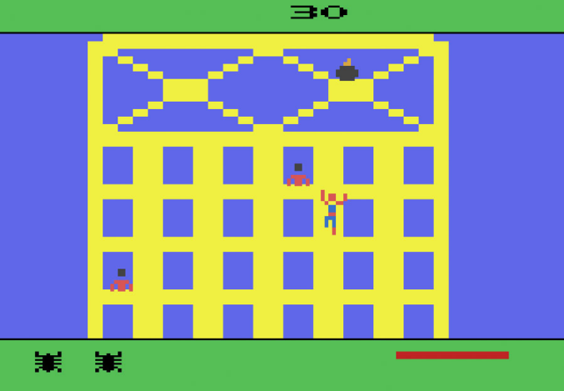

Do you have any thoughts on the aesthetics and gameplay of these early crossovers between comics and games? And any thoughts on the packaging and advertisements used to market these games?

10/ Have you ever encountered the Marvel graphic novel, Iron Man: Crash (1988), which declared itself to be the first computer generated graphic novel? This was created by Mike Saenz with assistance from computer programmer William Bates. And have you heard of DC Comics Batman: Digital Justice (1990)? The computer generated artwork was produced by Spanish comics creator and video games designer Pepe Moreno on a Macintosh II system with an 8bit/32bit colour board, a system palette of 16,000,000 possible colours, 8MB of RAM, a removable 45 MB hard disk drive and a 19” Trinitron monitor. These are landmarks in the history of digital comics, and arguably represent a crossover between the formal aspects of comics and the techniques employed in video game design. Is there any awareness of them in games circles?

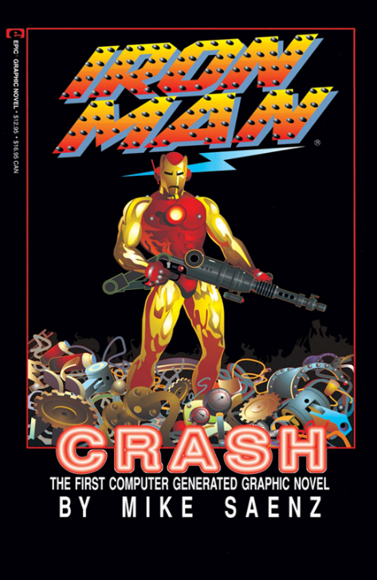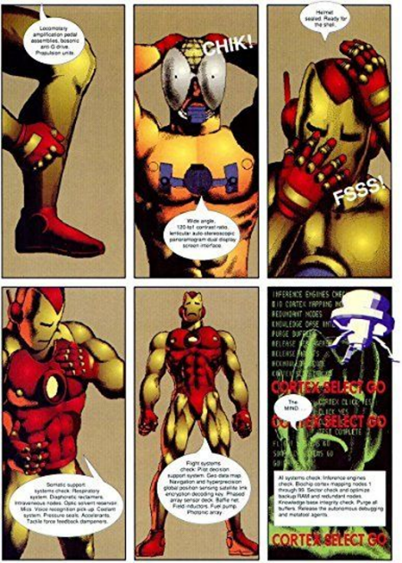

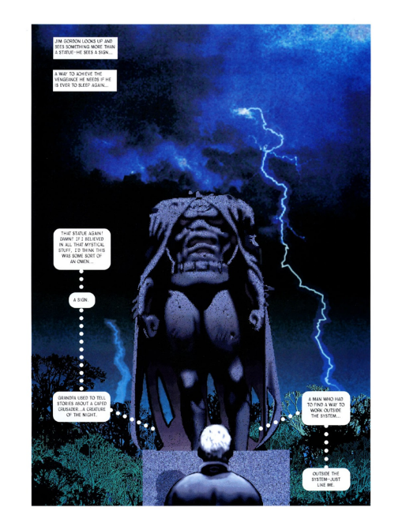
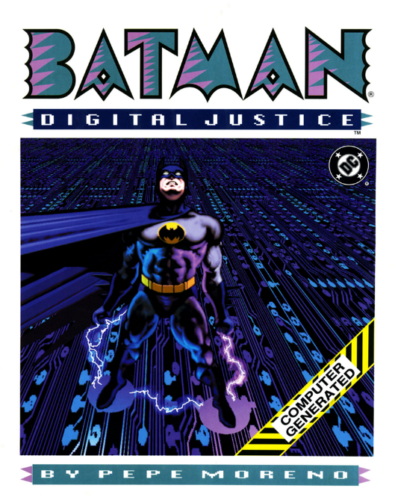

Do you have any thoughts on the aesthetics of these early digital comics in terms of how the artwork compares to video games of the late 1980’s and early ‘90s?

11/ Webcomics offer an interesting potential meeting point between comics and games. For example, Andrew Hussie's Homestruck was a webcomic that ran between 2009 and 2016. It is generally seen as one of the first webcomics to successfully exploit the multimedia possibilities of the webcomic medium. It was a text based interactive adventure that used flash animation. Are you aware of any webcomics that bring together aspects of comics and games?
12/ Are you aware of any games that have employed the formal aspects of comics? In Sega’s Comix Zone (1995) the player moves the hero, comics artist Sketch Turner, through the panels of his own comic. The villain, out in the real world, draws opponents onto the page/screen for the hero to interact with. Very meta! Are there any more recent examples of this?
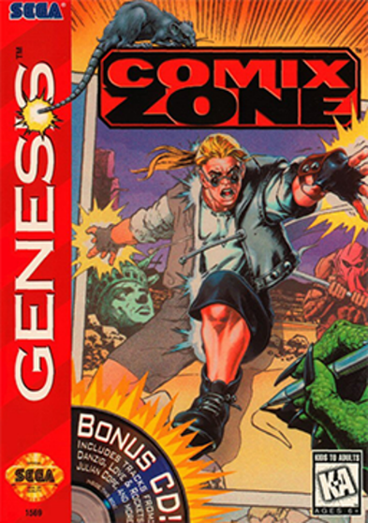
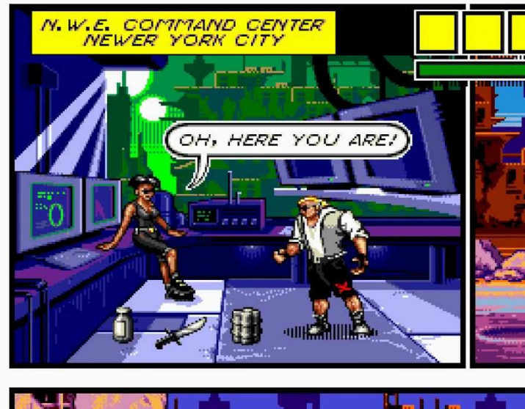

13/ Games scholar Jesper Juul has championed the idea that games are games, not stories. He has argued for the difference between storyworlds and story - that games often depict a storyworld, but don’t necessarily have a story (a fixed series of events told from a certain perspective). Games require what he calls the valorisation of ‘outcome’. You win or you lose, and you are usually motivated to win. Ludologists like Juul argue that narrative is a prosthesis of gameplay, an attachment that aids in the delivery of the game, but story is not essential to a game. What do you think?
14/ In his book Video Games and Storytelling: Reading Games and Playing Books (2015) Souvik Mukherjee notes that while games theory has not resolved this debate between narratology and ludology games theorist Steven E. Jones may have found a way through the impasse with his assertion that ‘games are complex social networks and that meaning flows through [them to] link up to other forms of media […] institutions and groups’ (p.8). Mukherjee himself argues that a game is an assemblage of parts operating across multiple levels and is necessarily in dialogue with elements outside of its own structure of rules and algorithms. So, in the same way that no story is just a story, separate from context, political and cultural associations, and ideological perspectives, no game is just a game. What do you think?

15/ Would you agree that the cultures of comics and gaming exist in close proximity to one another and form a complex network linking audiences, creators, and industries? If so, can you think of examples that the above questions have not covered? I’d love to hear about examples of this that I haven’t thought about!

